The following is a Screen shot of my log of commits to my “release” branch:

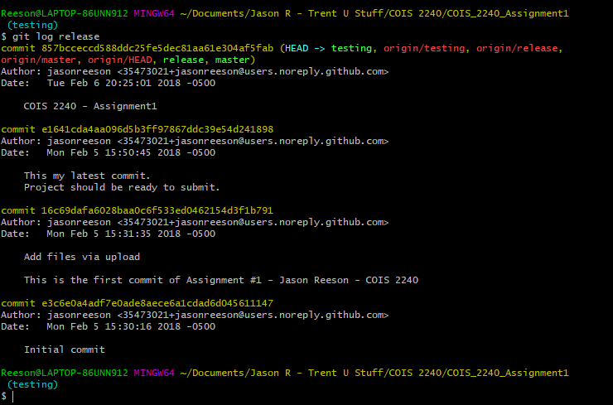

The following is a screen shot of the GitHub interface showing my “master” branch, “testing” branch and “release” branch. You will see that I made some changes to test and pushed them to test, then I pushed the same changes to release.

